Hubert Jay J. Lisas Project 2
CS231 Software Engineering | JP Vergara

In the first UML diagram, you have SIMServer, the main class, and TransactionParser, which reads all data from the input line, passes it back to SIMServer for processing. SIMServer processes all the operations indicated by the input. It instantiates the SubscriberList object, which in turn have two objects, Postpaid and Prepaid, which inherits some characteristics from the Subscriber object. The Postpaid object instantiates a SubscriberList object to kept track of all subscribers.

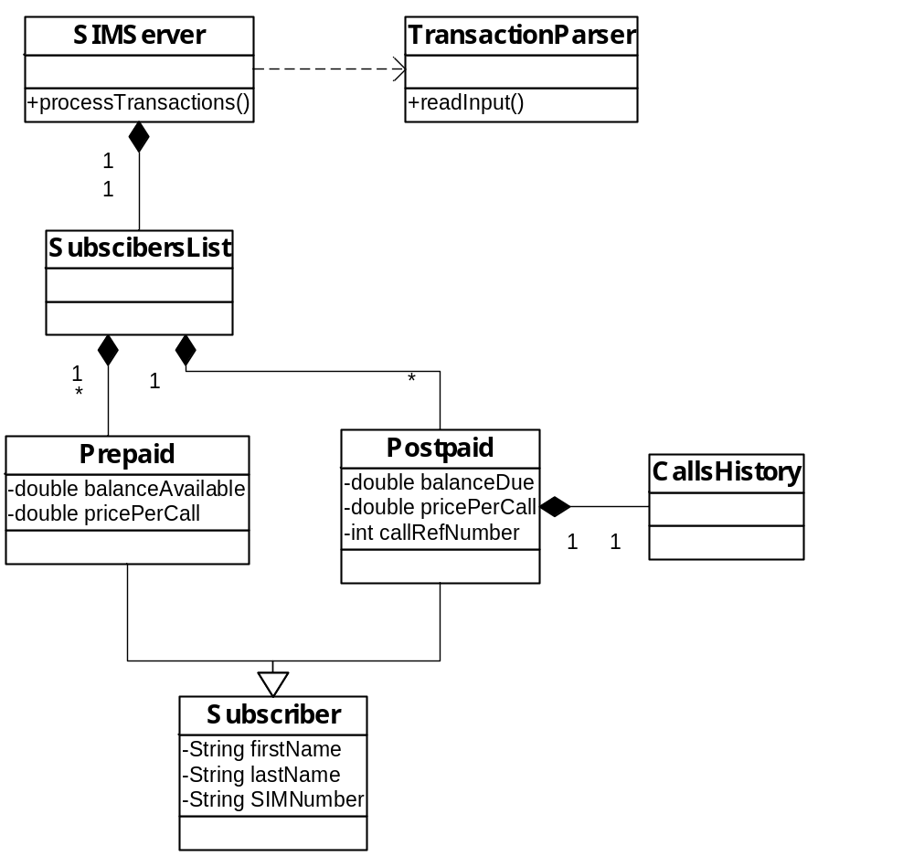

Preliminary Class Diagram

The final diagram only slightly resembles the original diagram. It still maintains the SIMServer class, it uses the TransactionServer, which in turn instantiates the SubscriberList and Subscriber objects. The Subscriber object also instantiates a Call object.

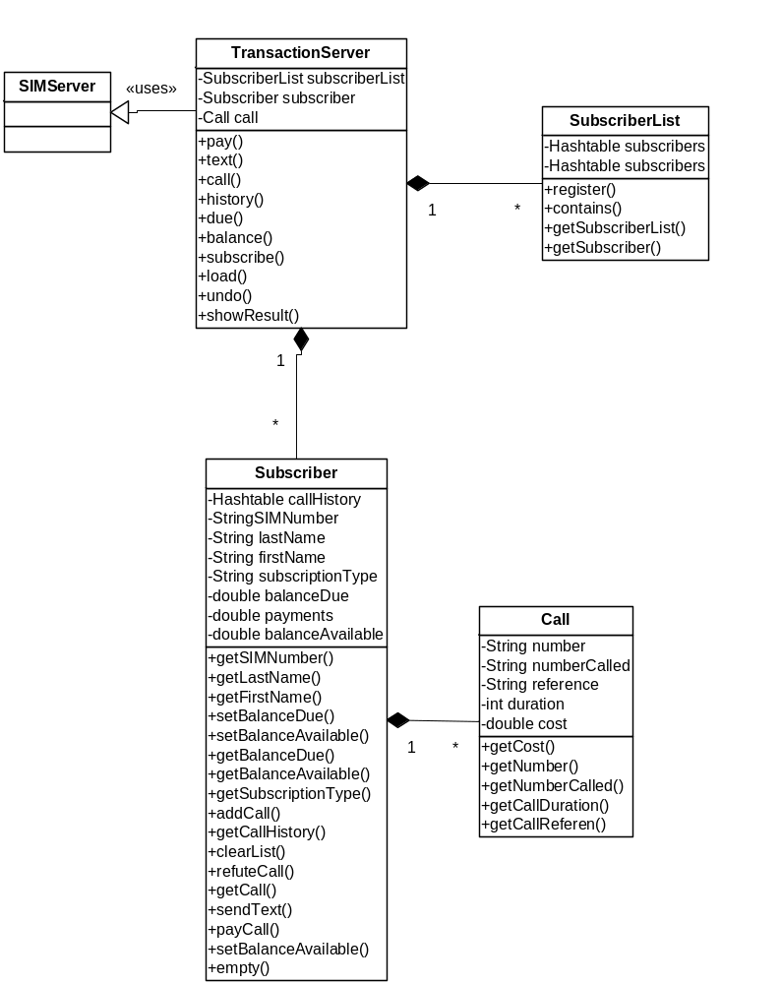

Final Class Diagram

